Nexus Network Journal (2020) 22:553–576



https://doi.org/10.1007/s00004-020-00479-z

**RESEARCH**



**Baldassare Peruzzi and Theatrical Scenery in Accelerated Perspective**

**Philip Steadman1**

Published online: 9 March 2020

© Kim Williams Books, Turin 2020

*accelerated perspective*

*Architecture*

*La Calandria*

*Le Bacchidi*

*Le Bacchidi*

**Keywords**

**\***



\554 P. Steadman

*On Architecture*

*intermezzi*

*orchestra*

*accelerated perspective*

*solidrelief perspectiveaccelerated*

*Le Bacchidi*

|  |  |
| --- | --- |
| Baldassare Peruzzi and Theatrical Scenery in Accelerated… | 555 |
|  |  |

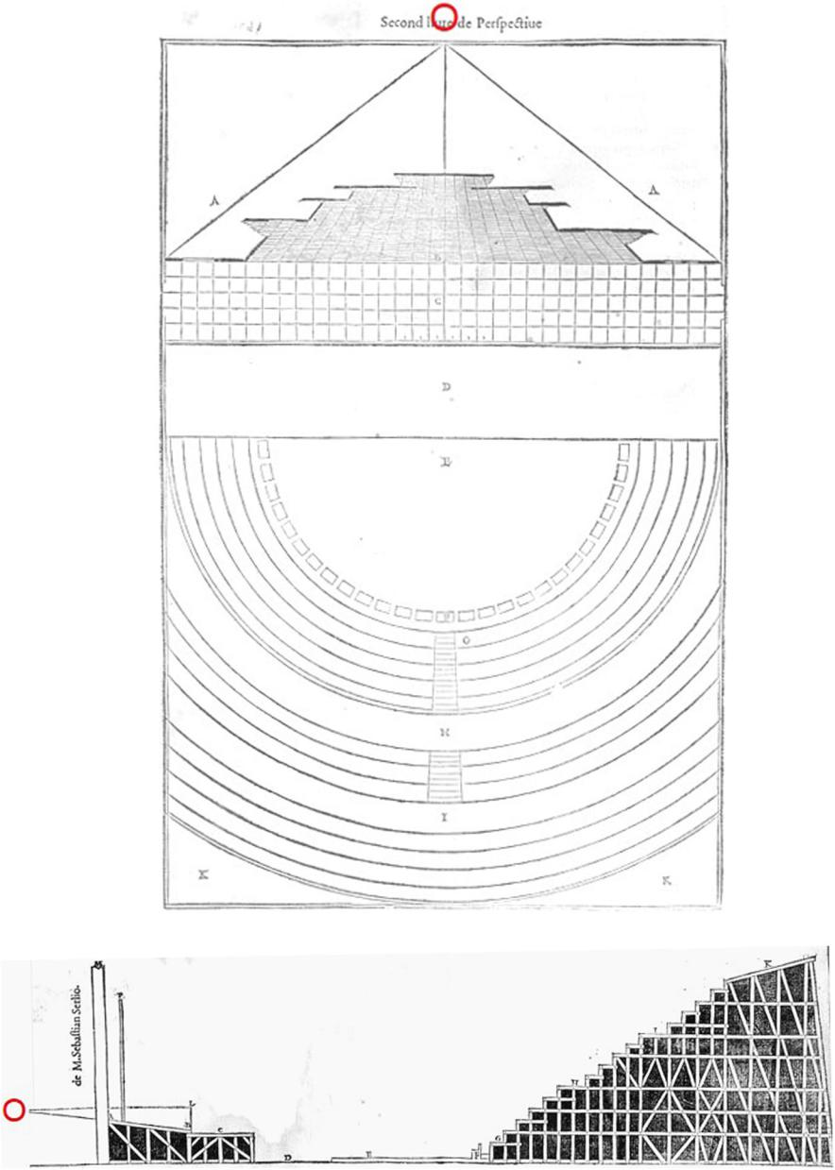

**Fig. 1**

\556 P. Steadman

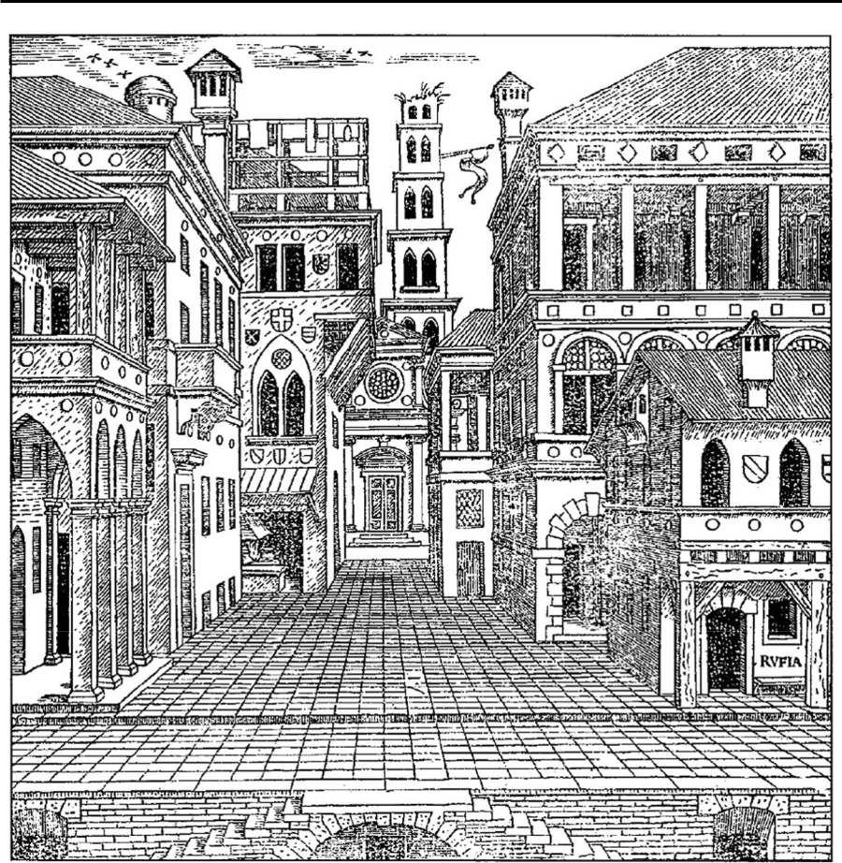

**Fig. 2**

|  |  |
| --- | --- |
| Baldassare Peruzzi and Theatrical Scenery in Accelerated… | 557 |
|  |  |

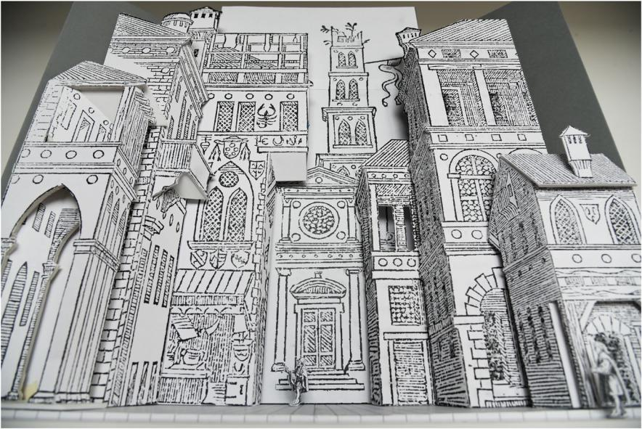

**Fig. 3**

…

\558 P. Steadman

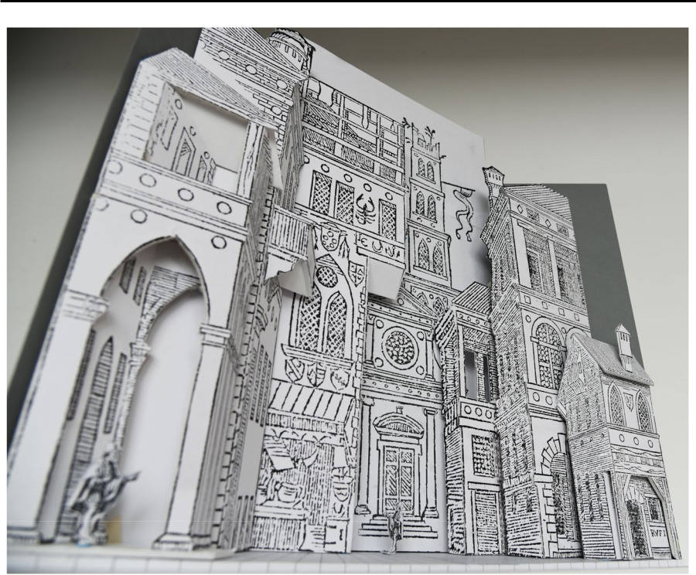

**Fig. 4**

|  |  |
| --- | --- |
| Baldassare Peruzzi and Theatrical Scenery in Accelerated… | 559 |
|  |  |

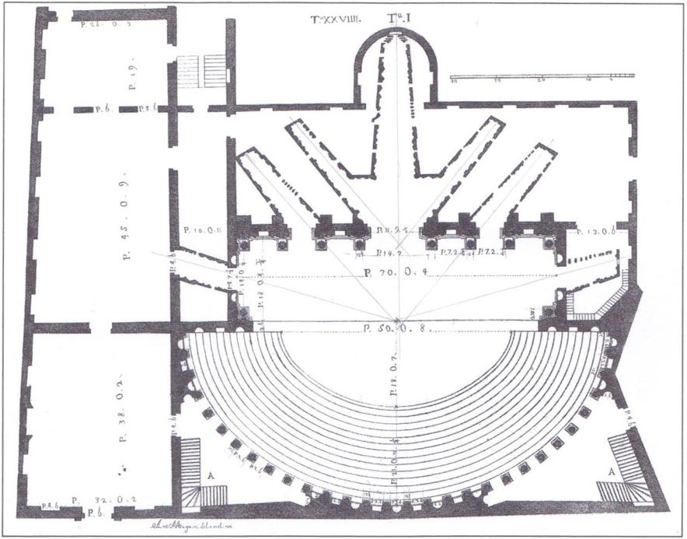

**Fig. 5**

*Le Fabbriche e i Disegni di*

*Andrea Palladio*

\560 P. Steadman

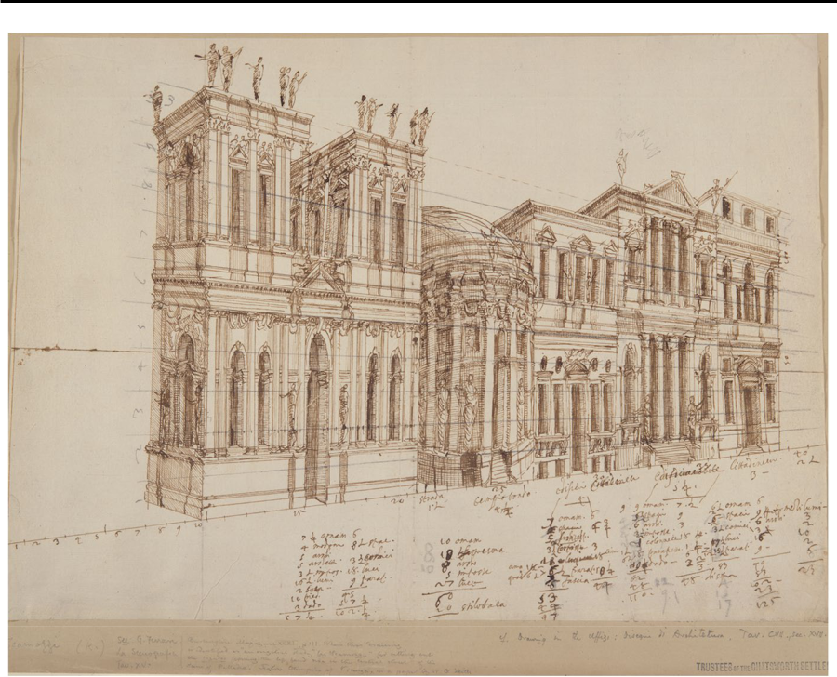

**Fig. 6**

*Life*

*Le*

*Bacchidi*

*Neither drawing is a*

*perspective*

|  |  |
| --- | --- |
| Baldassare Peruzzi and Theatrical Scenery in Accelerated… | 561 |
|  |  |

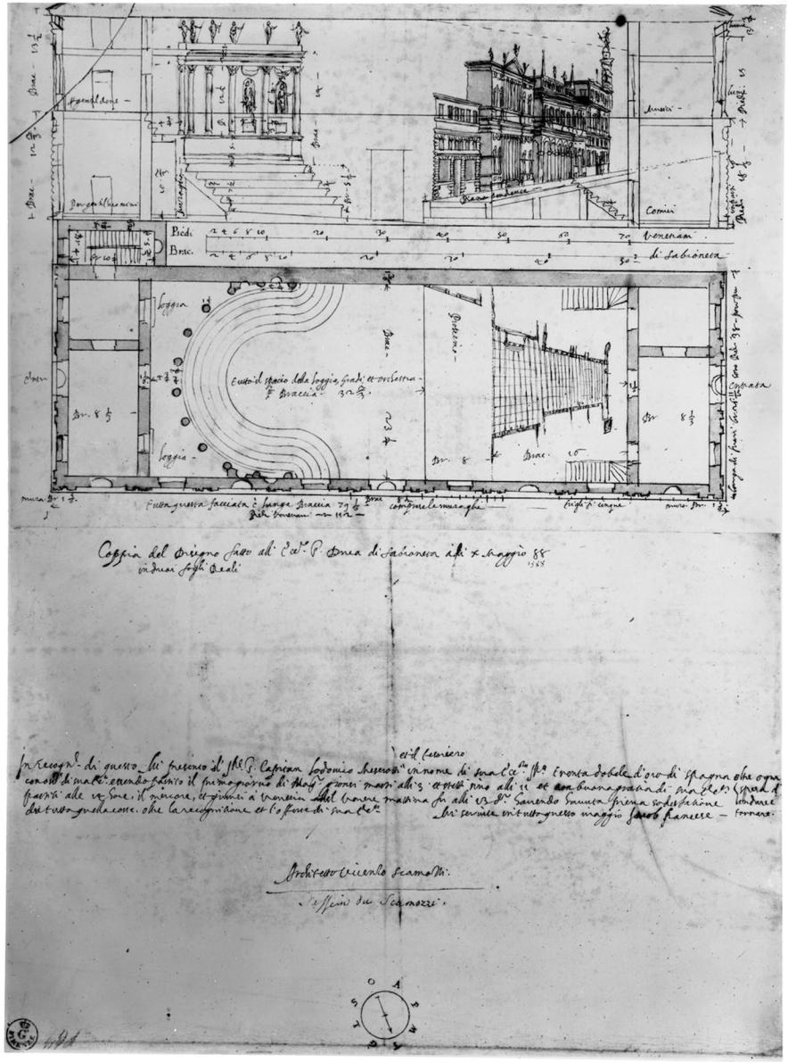

**Fig. 7**

\562 P. Steadman

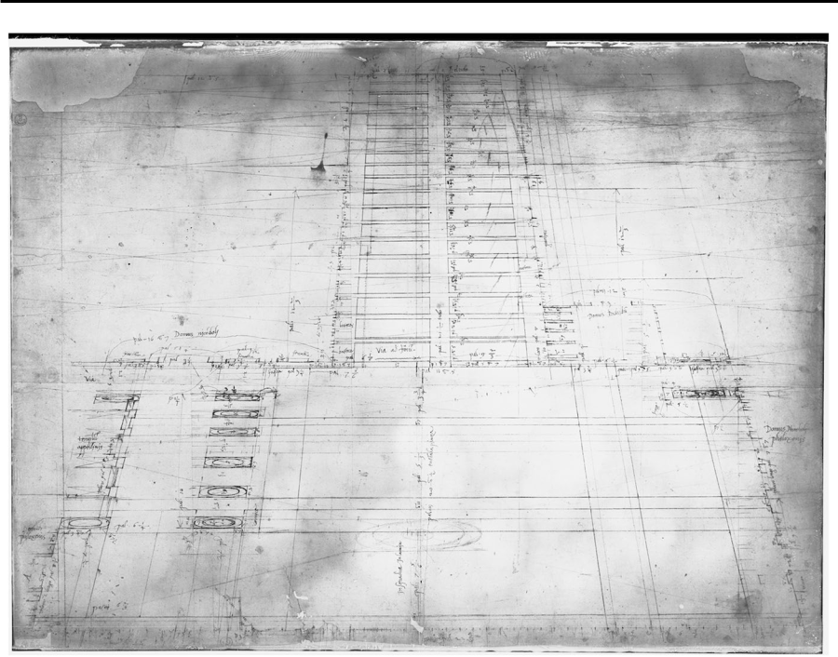

**Fig. 8** *Le Bacchidi*

*botega*

*Le Bacchidi*

|  |  |
| --- | --- |
| Baldassare Peruzzi and Theatrical Scenery in Accelerated… | 563 |
|  |  |

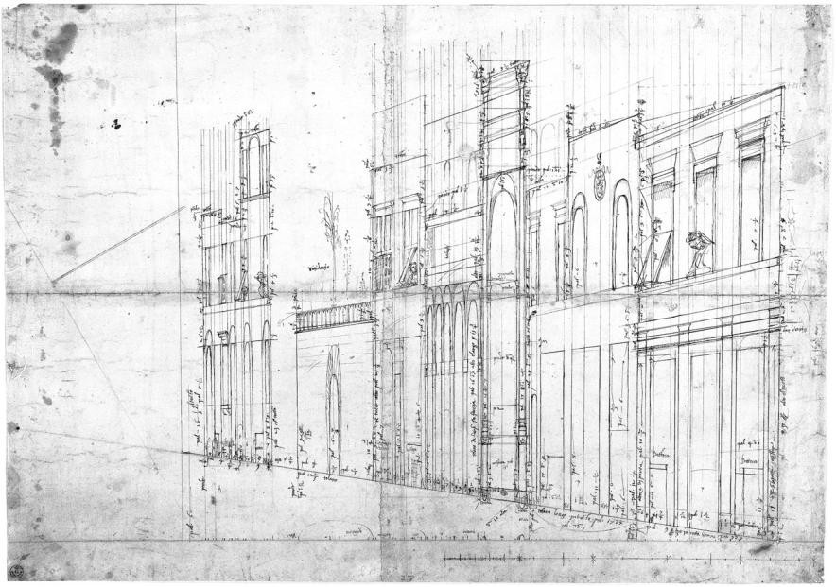

**Fig. 9** *Le Bacchidi*

…

\564 P. Steadman

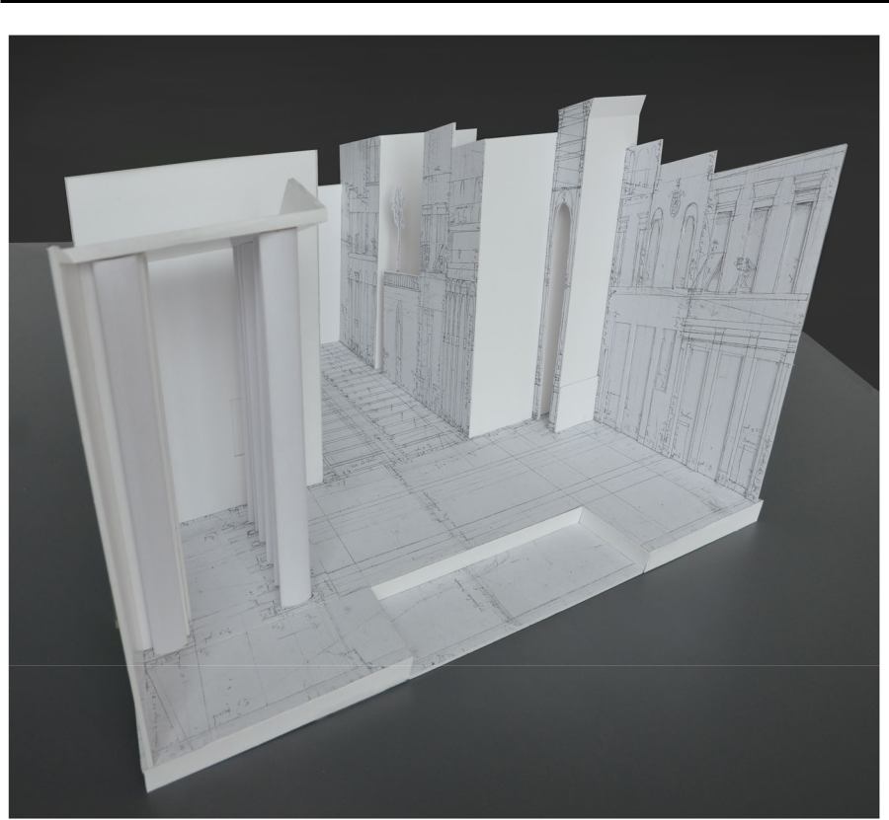

**Fig. 10** *Le Bacchidi*

*botega*

*Le Bacchidi*

*Life*

*La Calandria*

*Le Bacchidi*

*La Calandria*

*La*

*Calandria*

|  |  |
| --- | --- |
| Baldassare Peruzzi and Theatrical Scenery in Accelerated… | 565 |
|  |  |

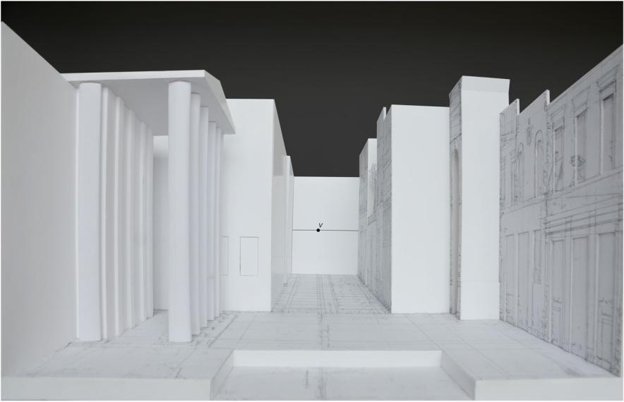

**Fig. 11** *Le Bacchidi*

*botega*

*La Calandria*

*Le Bacchidi*

*terminus post quem*

\566 P. Steadman

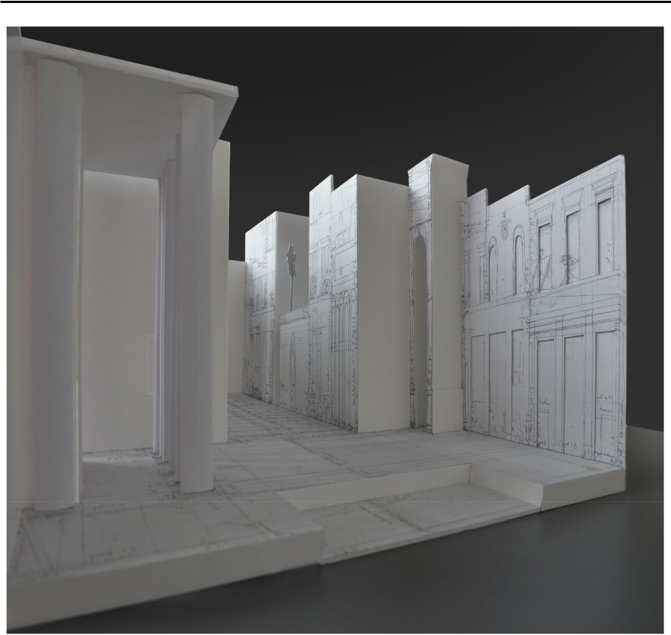

**Fig. 12** *Le Bacchidi*

|  |  |
| --- | --- |
| Baldassare Peruzzi and Theatrical Scenery in Accelerated… | 567 |
|  |  |

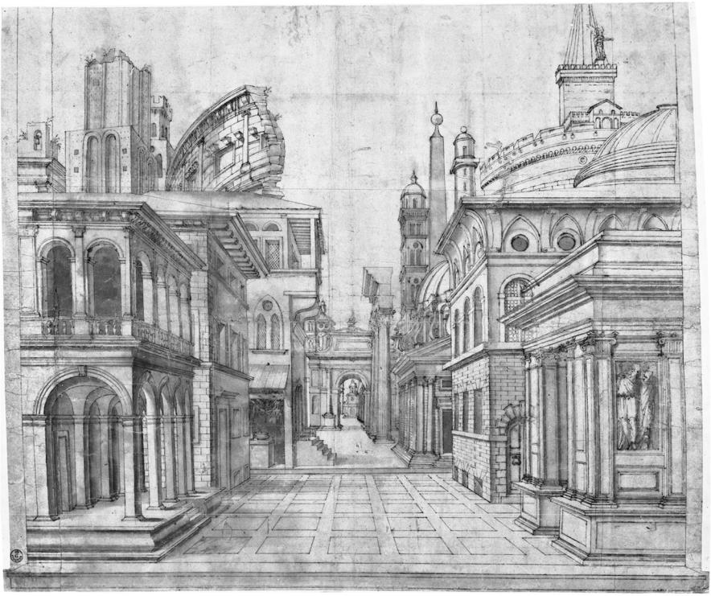

**Fig. 13** *La Calandria*

*Le Bacchidi*

\568 P. Steadman

**Fig. 14**

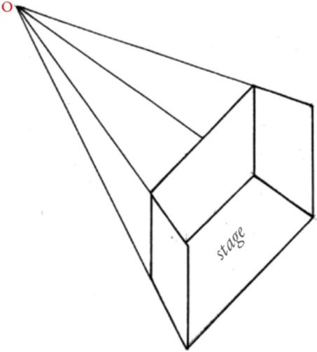

*Le Bacchidi*

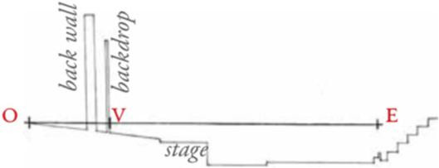

**Fig. 15**

*point of convergence*

*Le Bacchidi*

|  |  |
| --- | --- |
| Baldassare Peruzzi and Theatrical Scenery in Accelerated… | 569 |
|  |  |

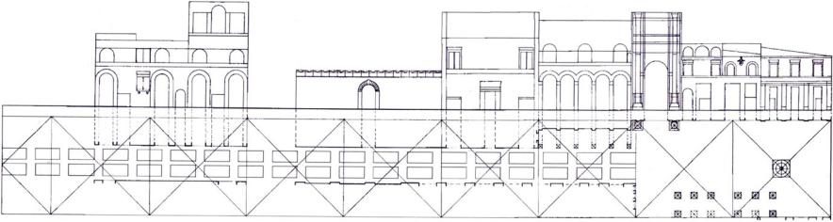

**Fig. 16**

*Le Bacchidi*

**Fig. 17**

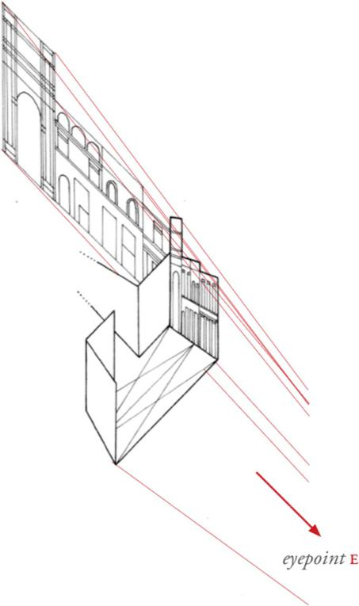

*Le*

*Bacchidi*

\570 P. Steadman

|  |  |
| --- | --- |
| Baldassare Peruzzi and Theatrical Scenery in Accelerated… | 571 |
|  |  |

**Fig. 18**

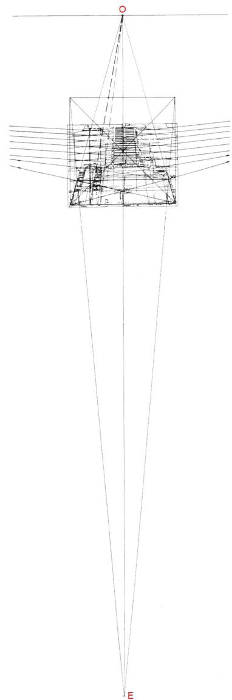

*Le Bacchidi*

\572 P. Steadman

*trompe l’oeil*

*very*

*trompe l’oeil*

*Le Bacchidi*

*Le Bacchidi*

*Flagellation of Christ*

*De prospectiva*

*pingendi*

|  |  |
| --- | --- |
| Baldassare Peruzzi and Theatrical Scenery in Accelerated… | 573 |
|  |  |

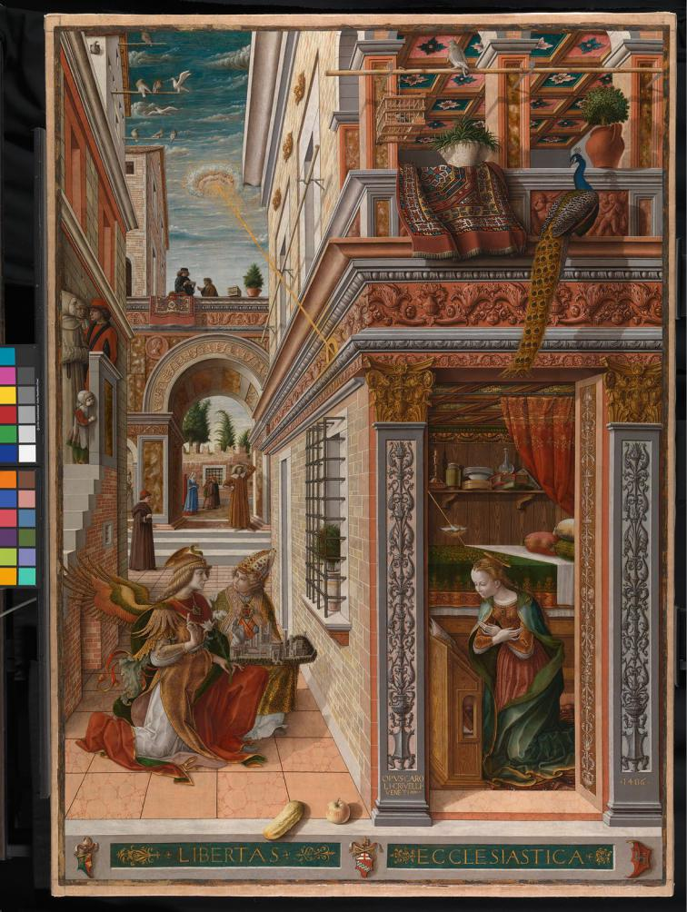

**Fig. 19** *The Annunciation, with Saint Emidius*

*The Ideal City*

\574 P. Steadman

*The Annunciation, with Saint Emidius*

*istoria*

*The Washing of the Feet*

*Pratica di Fabricar Scene e Machine ne’ Teatri*

*Trattato sopra la Struttura de’ Theatri e Scene*

|  |  |
| --- | --- |
| Baldassare Peruzzi and Theatrical Scenery in Accelerated… | 575 |
|  |  |

*Lo Spazio Scenico*

**Acknowledgements**

*Theatre Design and Technology*

*Scenes and Machines on the English Stage During the Renaissance*

*Trattato sopra la struttura de’theatri e scene*…

é*Fables, formes, fgures*

*Bolletino del Centro*

*Internazionale di Studi di Architettura Andrea Palladio*

*The Origin of Perspective*

*La Calandria*

*Renaissance Studies*

*Computers in the History of Art*

*The Renaissance Stage: Documents of Serlio, Sabbattini and Furttenbach*

*Becoming an Architect in Renaissance Italy. Art, Science, and the Career of Baldassare Peruzzi*

*DisegnareCon*

*Perspectivae libri sex*

*Gazette des*

*Beaux Arts*

*Quarterly Journal of Speech*

*The Theatrical Writings of Fabrizio Carini Motta*

*Journal of the Warburg and Courtauld*

*Institutes*

*Teatri Italiani del cinquecento*

*Lo spazio scenico: teorie e tecniche scenografche in Italia dall’eta’ Barocca al Settecento*

*The*

*Renaissance Stage: Documents of Serlio, Sabbattini and Furttenbach*

*Vasari on Theatre*

*Encyclopedia of World Art*

\576 P. Steadman

*Li due Orfei, da Poliziano a Monteverdi*

*Perspectiva pictorum et architectorum/ Prospettiva de’ pittori e architetti*

*Pratica di fabricar scene e machine ne’ teatri*

*The*

*Renaissance Stage: Documents of Serlio, Sabbattini and Furttenbach*

*Il secondo libro di perspettiva*

*The Renaissance Stage: Documents of Serlio, Sabbattini and*

*Furttenbach*

*Una storia della scena prospettica dal Rinascimento al Barocco*

*Le due regole della prospettiva pratica.*

**Publisher’s Note**

**Philip Steadman**

*Form*

*Vermeer’s Camera*